📄 Milestone 1 Report
AI-Driven Revenue Analysis for Hotels
Milestone 1: Orientation & Data Loading

1. Introduction
In the hospitality industry, revenue optimization and occupancy management are critical factors that directly influence profitability. Hotels generate large volumes of booking data every day, but without proper analysis, this data cannot be effectively utilized for decision-making.
The objective of this project, AI-Driven Revenue Analysis for Hotels, is to analyze historical hotel booking data and derive meaningful revenue insights using Power BI. The ultimate goal is to enable data-driven decisions related to pricing, cancellations, customer segmentation, and booking trends.
Milestone 1 focuses on understanding the dataset structure, loading the data into Power BI, and performing systematic preprocessing and cleaning to prepare the dataset for further modeling and business analysis.

2. Dataset Source and Description
The dataset used for this project was collected from Kaggle, a widely recognized platform for real-world datasets and machine learning projects.
Access the dataset here:
🔗 https://www.kaggle.com/code/farzadnekouei/hotel-booking-cancellation-prediction/input

2.1 Dataset characteristics:
- Domain: Hospitality / Hotel Bookings
- Time period: 2015 – 2017 (3 years)
- Type: Historical booking transactions
- Granularity: One row per booking
- Size: ~120,000+ records
- Format: CSV
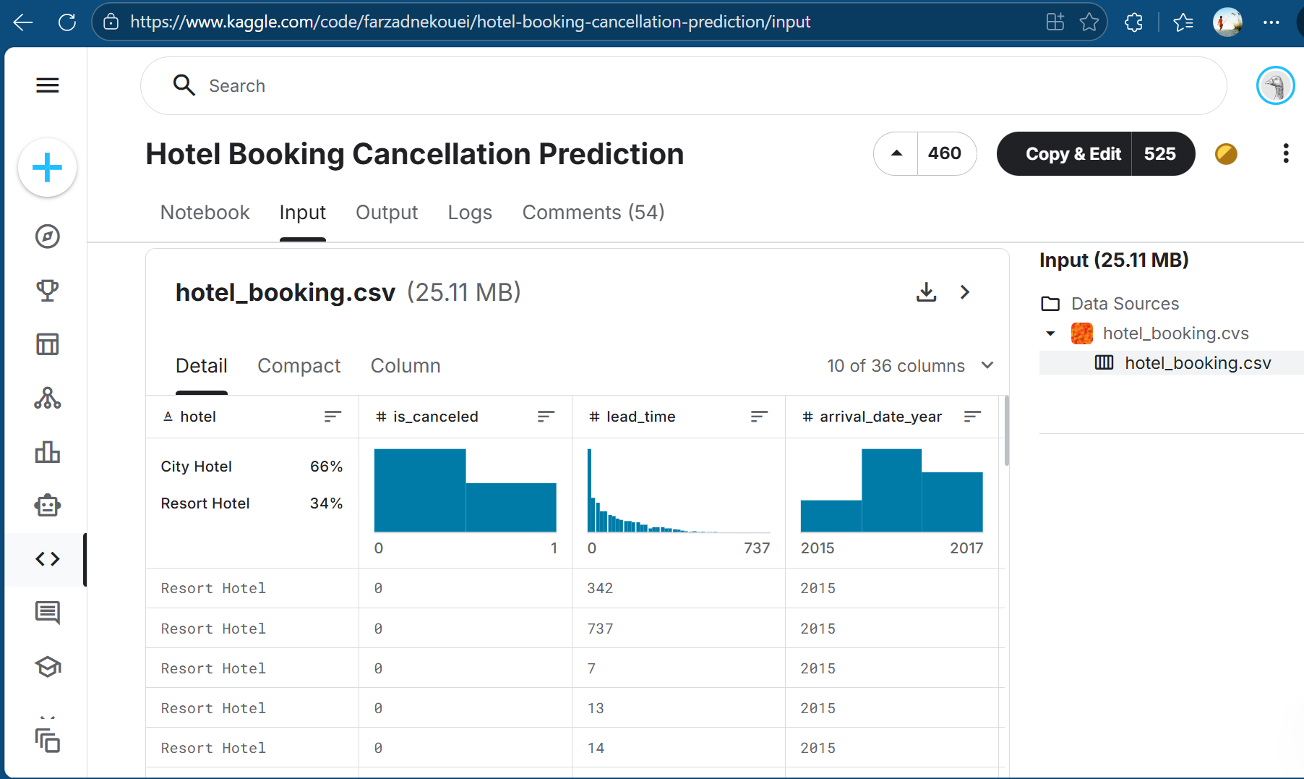
This multi-year dataset allows the analysis of:
- Seasonal trends
- Yearly revenue growth
- Cancellation patterns
- Customer behavior changes over time
Using three years of data provides sufficient historical depth for building meaningful analytical insights and future AI-driven forecasting models.

3. Objective of Milestone 1
The primary objective of this milestone is to transform raw booking data into a clean and structured dataset ready for analysis.
Key goals include:
- Understanding dataset structure
- Importing data into Power BI
- Identifying data quality issues
- Cleaning missing and inconsistent values
- Assigning correct data types
- Creating derived business columns
- Preparing data for modeling and DAX calculations
Without proper preprocessing, business metrics such as revenue and cancellation rate would be inaccurate.

4. Data Loading Process
The dataset was imported into Power BI Desktop using the Get Data functionality. 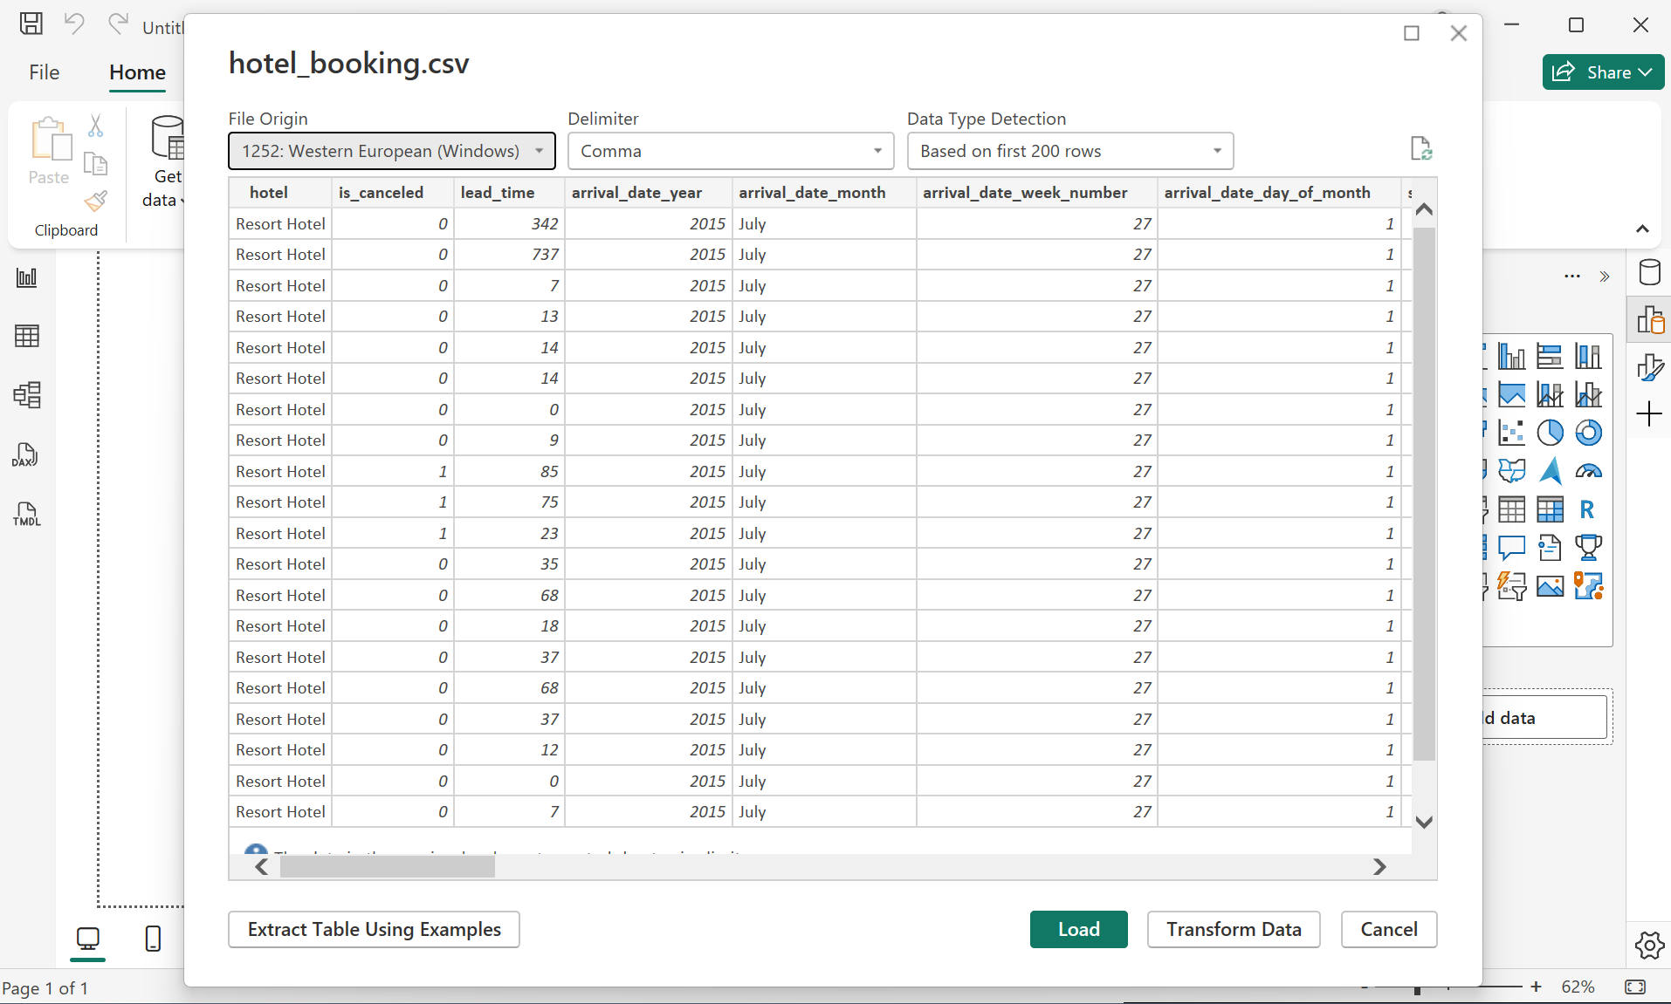 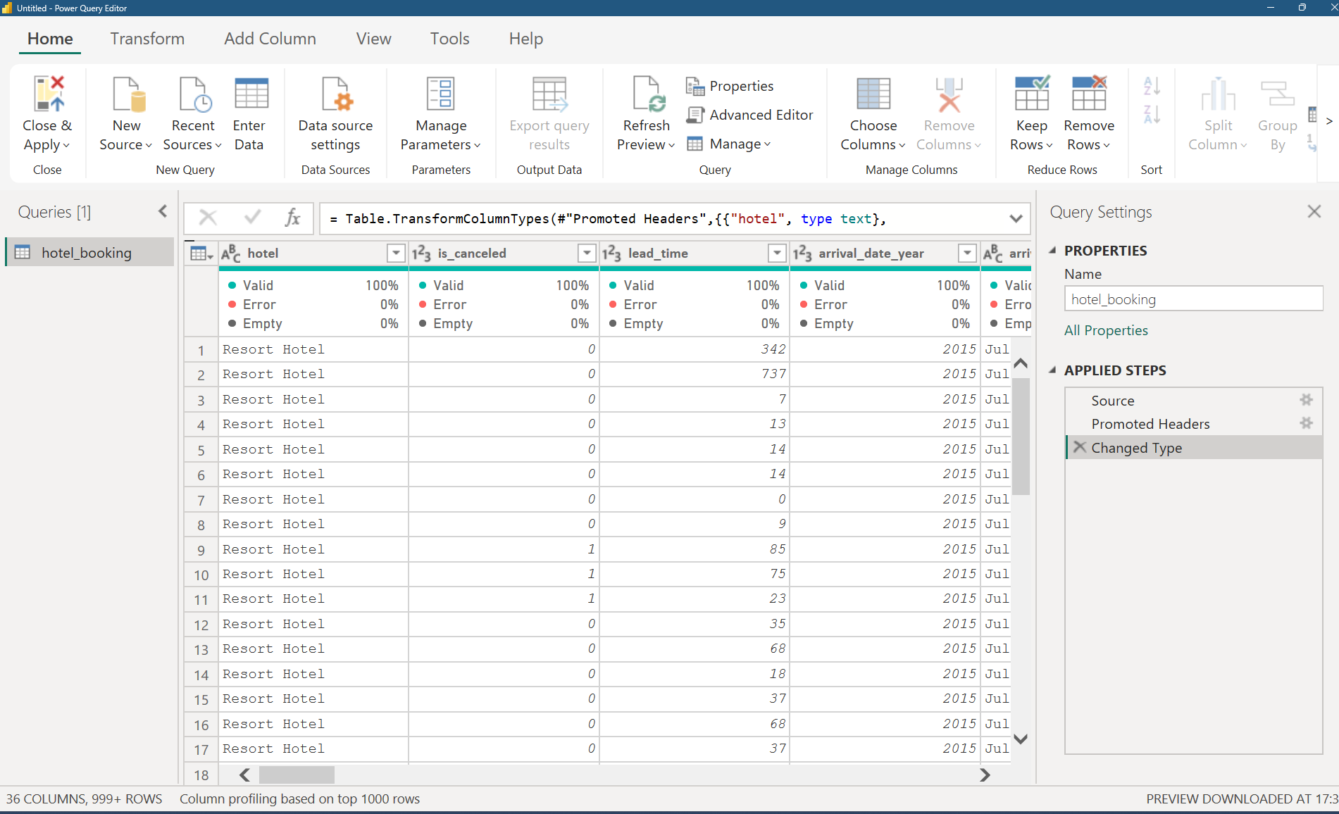
Steps performed:
- Loaded CSV file into Power BI
- Opened Power Query Editor
- Promoted first row as column headers
- Inspected preview for structure and correctness
Power Query Editor was selected for transformation because it allows repeatable and automated preprocessing steps before loading the data model.
This ensures:
- faster dashboards
- reduced memory usage
- better performance

5. Data Cleaning and Preprocessing
Raw datasets typically contain inconsistencies such as null values, incorrect formats, and irrelevant fields. Multiple preprocessing steps were performed to ensure high data quality.

5.1 Removing Irrelevant Columns
Columns containing personally identifiable information were removed:
- Name
- Email
- Phone number
- Credit card
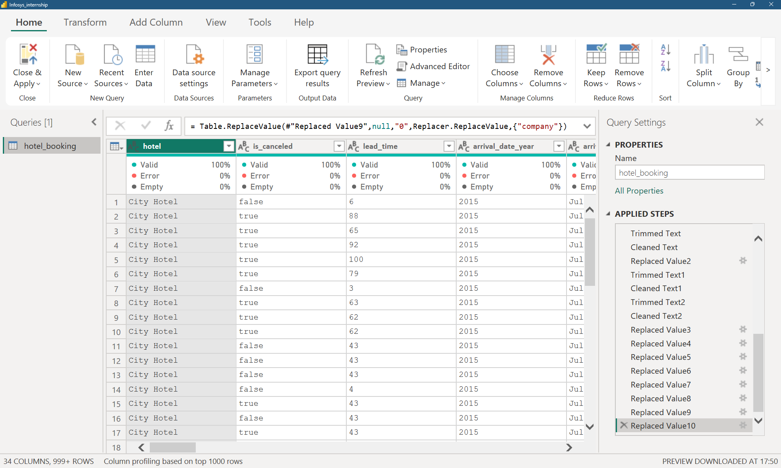
Reasons:
- No contribution to revenue analysis
- Increased memory usage
- Privacy and security concerns
Removing unnecessary attributes improved performance and simplified the data model.

5.2 Data Type Standardization
Correct data types were assigned to all fields:

Data Type | Example Columns
Whole Number | nights, adults, bookings
Decimal | ADR
Date | reservation date
Text | country, segment
Boolean | cancellation flag
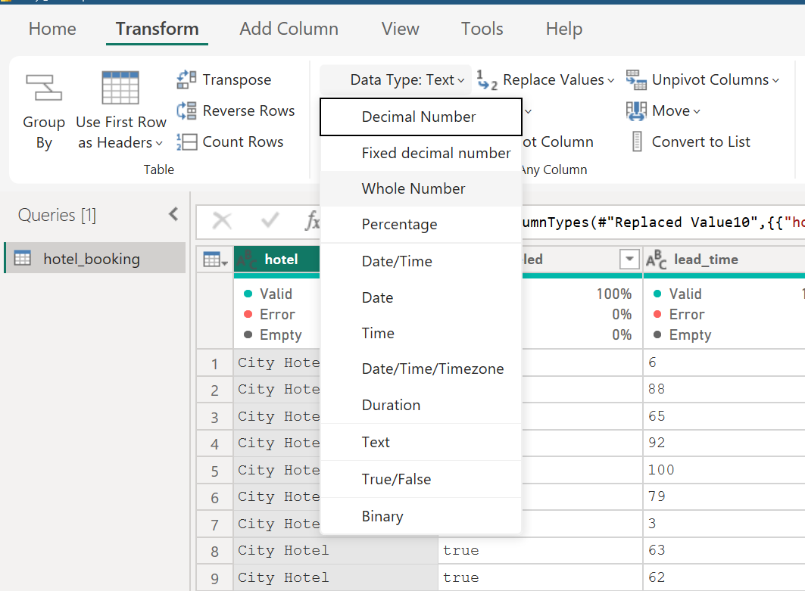
Correct types ensure:
- accurate calculations
- faster queries
- reliable aggregations

5.3 Handling Missing Values
Missing values were handled logically based on business meaning rather than blindly deleting records.
Column | Treatment | Reason
children | replaced with 0 | no children present
agent | replaced with 0 | direct booking
company | replaced with 0 | individual booking
country | replaced with “unknown” | missing category
This approach preserved revenue records while maintaining data integrity.

5.4 Cleaning Blank and Inconsistent Text
Text inconsistencies such as:
- extra spaces
- empty strings
- mixed case values
were corrected using:
- Trim
- Clean
- Replacement with null/standard values
This ensures proper grouping in reports and avoids fragmented categories.

5.5 Creation of Derived Business Columns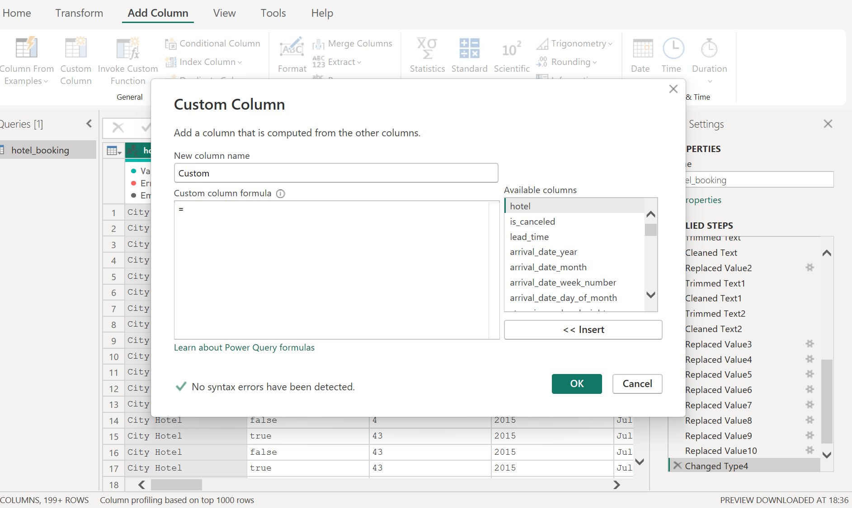
To simplify analysis, new calculated fields were created.
Total Nights
Represents the total stay duration:
weekend nights + weekday nights
Total Nights = stays_in_weekend_nights + stays_in_week_nights
Revenue
Represents booking revenue:
ADR × Total Nights
Revenue = ADR × Total Nights
Canceled bookings were assigned zero revenue.
These derived columns reduce complexity in later calculations and improve performance.

6. Data Validation
After preprocessing, several checks were performed:
- No critical null values remain
- Correct data types applied
- Revenue calculation verified
- Canceled bookings generate zero revenue
- Dataset reduced to relevant fields only
This ensures reliable inputs for modeling and analytics.

7. Outcome of Milestone 1
At the end of this milestone:
- Raw data was successfully loaded into Power BI
- Data inconsistencies were resolved
- Missing values handled logically
- Derived revenue metrics created
- Dataset optimized for performance
The data is now fully prepared for:
- Milestone 2: Data Modeling
- Milestone 3: DAX & Business Metrics
- Milestone 4: Visualization & AI-driven insights
This clean and structured foundation enables accurate and meaningful revenue analysis. These preprocessing steps ensure accurate revenue computation, eliminate inconsistencies, improve model performance, and provide a reliable foundation for further analytical modeling and visualization.

8. Next Steps – Upcoming Milestones
After completing data loading and preprocessing, the dataset is now clean, consistent, and ready for analytical modeling. The prepared data will be used in the subsequent milestones to extract business insights and build an AI-driven revenue intelligence solution.
Milestone 2 – Data Loading & Modeling
In the next phase, the cleaned dataset will be structured into an optimized data model within Power BI. Relationships between tables will be established, calculated fields will be refined, and the model will be designed to ensure efficient querying and scalability. Proper modeling will improve performance and enable accurate aggregations.
Milestone 3 – DAX & Business Metrics
Advanced DAX measures will be created to compute key performance indicators such as:
- Total Revenue
- Average Daily Rate (ADR)
- Occupancy Rate
- Cancellation Rate
- Revenue per Booking
- Revenue trends over time
These metrics will help evaluate hotel performance and support data-driven decision-making.

Milestone 4 – Visualization, Storytelling & AI
Finally, interactive dashboards will be developed to visualize trends and patterns in bookings, pricing, and revenue. Insights will be presented using charts, KPIs, and filters to support business storytelling. AI-driven features such as forecasting and trend analysis will be incorporated to predict future revenue and assist strategic planning.
Overall, these milestones will transform raw booking data into actionable intelligence for hotel revenue optimization.

